Day 3
- What do you understand by big O notation?
Big O notation is a way to describe how the running time or the memory usage of an algorithm grows as the input increases.
- Array and its types?
Array is a collection of the elements of same data types.
Types – 1. 1D, 2D, Multidimensional, Jagged Array.
- String in Java?
Sequence of character to store data.
Task 5:
Program to reverse a given string?
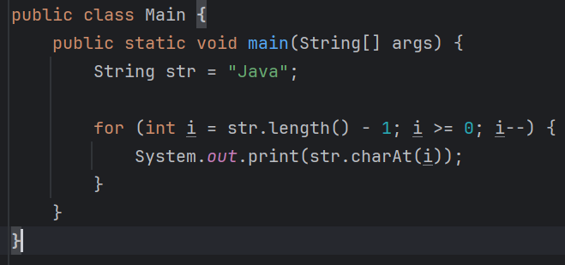
Task 6: Static and normal variables
Task 7: Wap to print number from 100 to 10

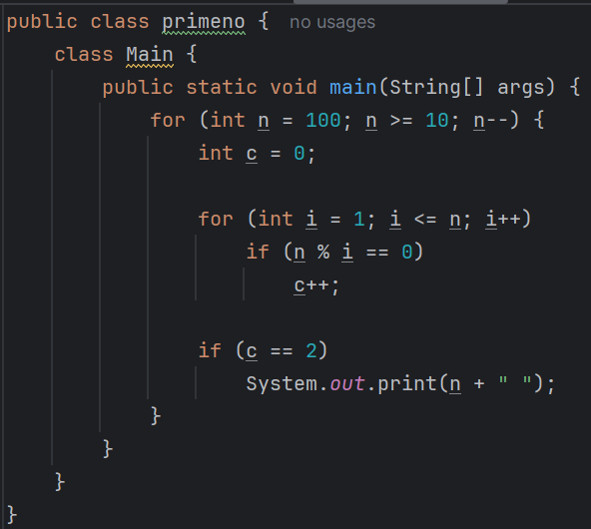
Task 8:
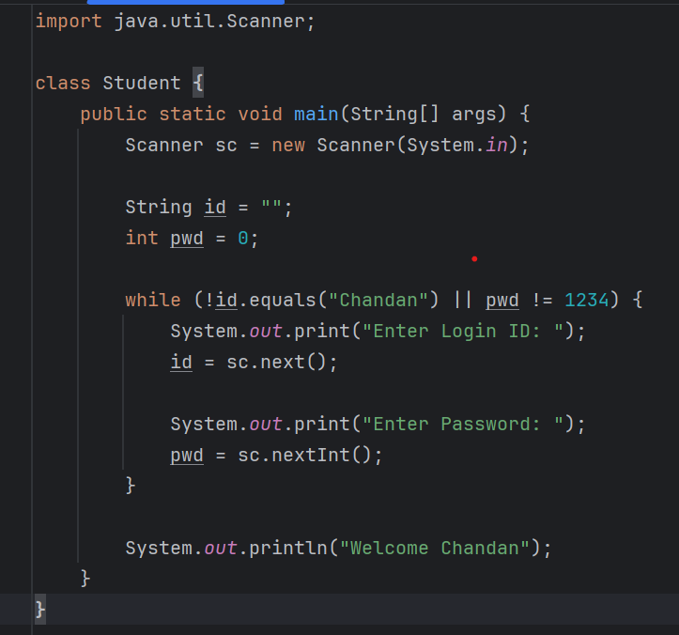
Task 10:
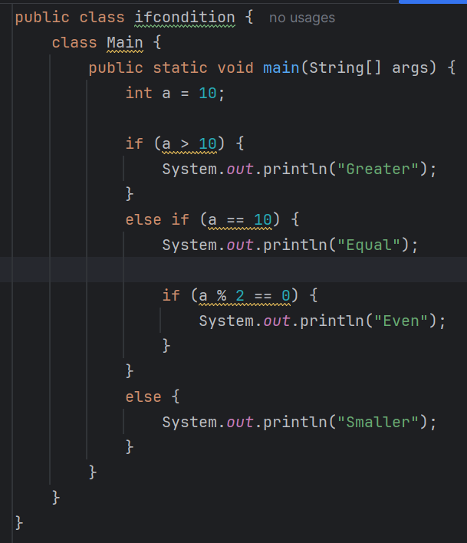
Task 11:
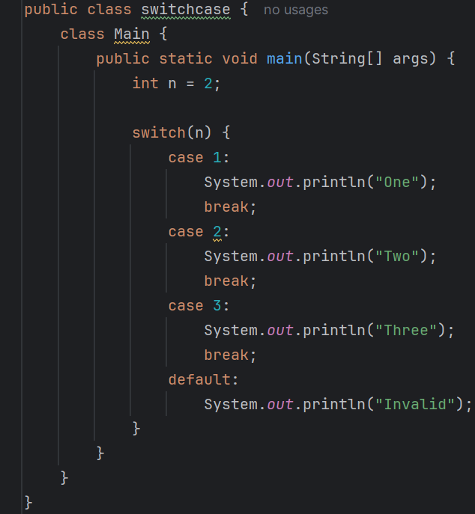
Task 12:
Keywords that control the visibility of classes, variables, methods. They help in protecting data and controlling where the members can be used.
Task 14:
Break – Stops the entire loop, Control moves outside the loop
Continue - Skips only the current iteration.

